CERTIFICATE

This is to certify that the project titled “ApnaStay — Student Accommodation & Mess Discovery Platform” submitted by Harsh, Enrolment No. 00116404525, towards partial fulfilment of the requirements for the award of the degree Masters of Computer Applications (SE), ICT-669, is a Bonafide work carried out under my supervision.
The work embodied in this research paper is original and has not been submitted to any other University or Institution for the award of any degree or diploma.

Yashima Hooda
Assistant Professor, USIC&T

ACKNOWLEDGEMENT

I would like to express my sincere gratitude to my supervisor, Ms. Yashima Hooda, Assistant Professor, USIC&T, for her valuable guidance, encouragement, and continuous support throughout the preparation of this NUES Project.
I am also thankful to the faculty members of the University School of Information Communication and Technology, Guru Gobind Singh Indraprastha University, for providing the necessary resources and a conducive environment for completing this work.
Finally, I extend my heartfelt thanks to my family and friends for their constant support and motivation.

Date: __/__/2025 Signature

🏠 ApnaMess — Mess & Flat Hunting Platform

A modern, full-stack web platform designed to simplify accommodation and food service discovery for college students, interns, and working professionals across major educational and IT hubs (e.g., Bangalore, Delhi, Kota, Pune).
The platform connects users with verified PGs (Paying Guest accommodations), Shared/Full Flats, and Mess & Food Facilities, enabling seamless search, instant booking requests, direct landlord WhatsApp communication, an integrated admin management dashboard, and an AI-powered chatbot trained on custom Q&A data.

✨ Features

🔍 For Students & Seekers
- Multi-Criteria Search & Filtering — Filter by Category (PG, Flat, Mess), Location, Area, Furnishing Status, Budget, and keywords
- Rich Accommodation Details — Image galleries, price breakdowns, room types, amenities, and owner profiles
- Instant One-Click Booking — Submit reservation requests with move-in dates and stay duration
- Direct WhatsApp Integration — Contact property owners via pre-configured WhatsApp chat links
- 🤖 AI Chatbot Assistant — Floating chat bubble powered by a custom-trained ML model with typing indicators and smart fallback responses

🛡️ For Administrators & Property Owners
- Full CRUD for Listings — Create, edit, toggle availability, or delete properties with multi-image support
- Booking Request Dashboard — View, filter (Pending, Confirmed, Rejected), approve/reject bookings
- One-Click Database Seeder — Populate MongoDB with high-quality sample listings across multiple cities

🛠️ Developer & Integration Features
- In-App API Guide — Interactive Postman documentation modal baked into the frontend
- Robust MongoDB Connection — Built-in Google DNS fallback to fix Windows SRV lookup issues with Atlas
- Custom-Trained NLP Model — TF-IDF + Logistic Regression trained on 74+ Q&A pairs, served via Flask

🏛️ System Design

High-Level Architecture
The application follows a three-tier microservice architecture composed of independently deployable services that communicate over a shared Docker bridge network in production.
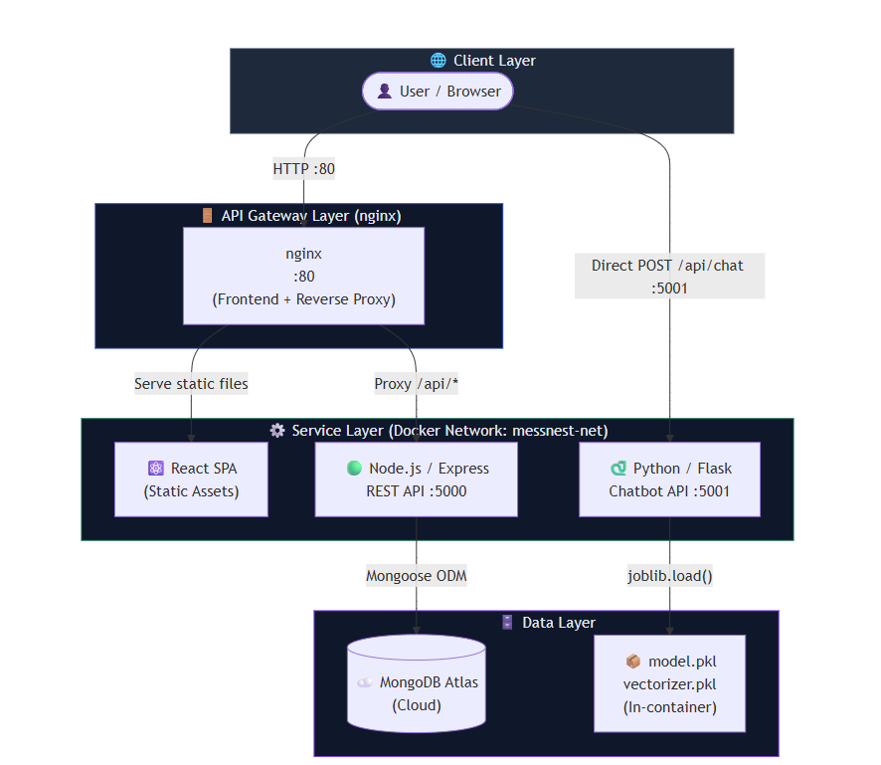

Request Flow
This diagram traces the complete lifecycle of two core user journeys.
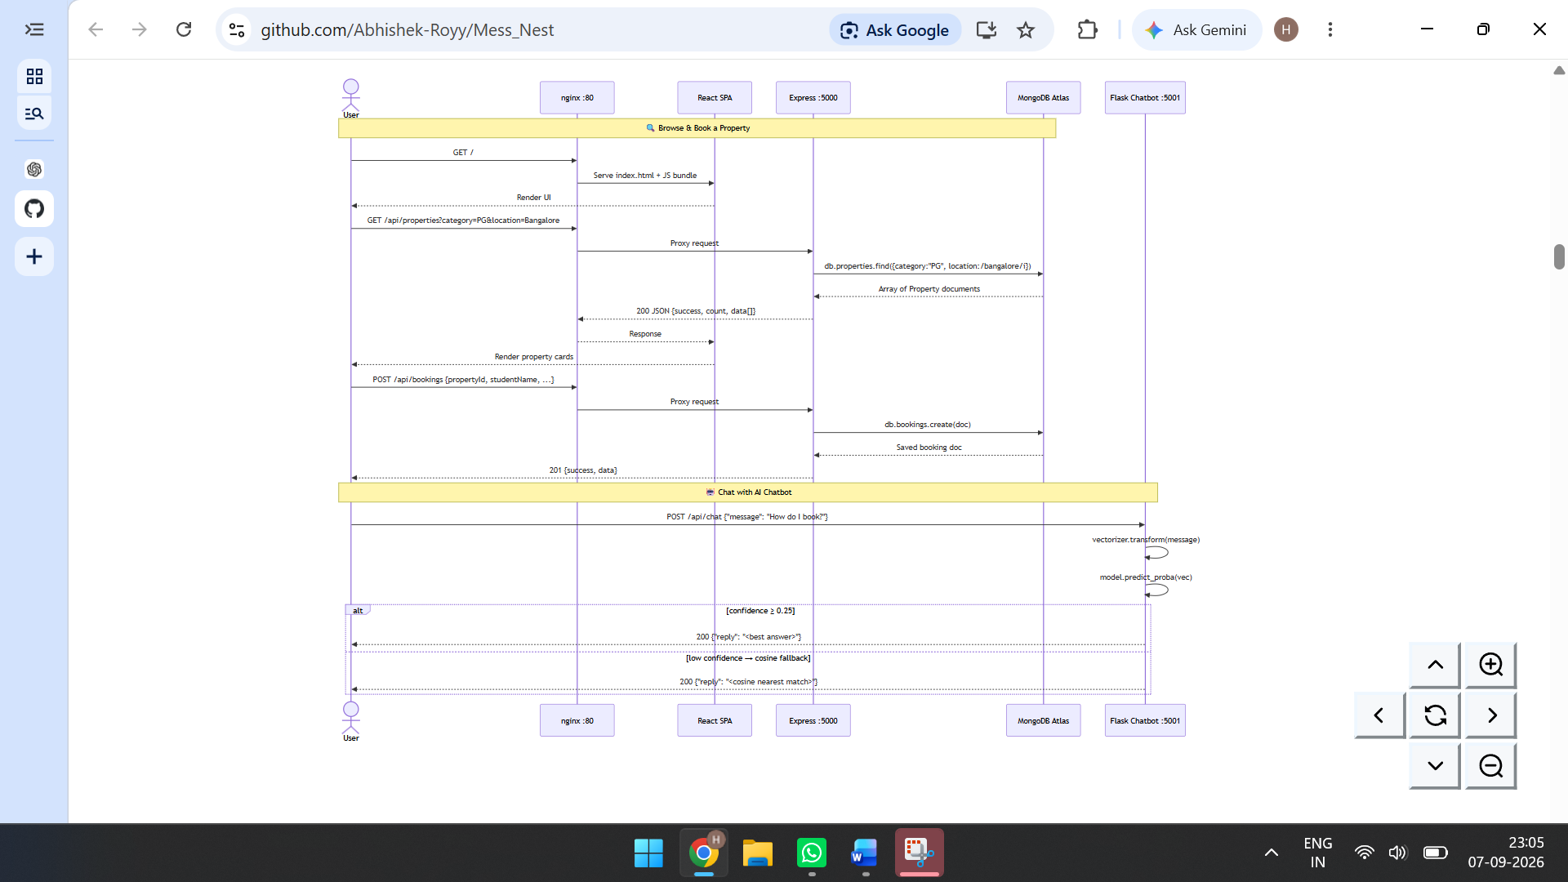

Data Model
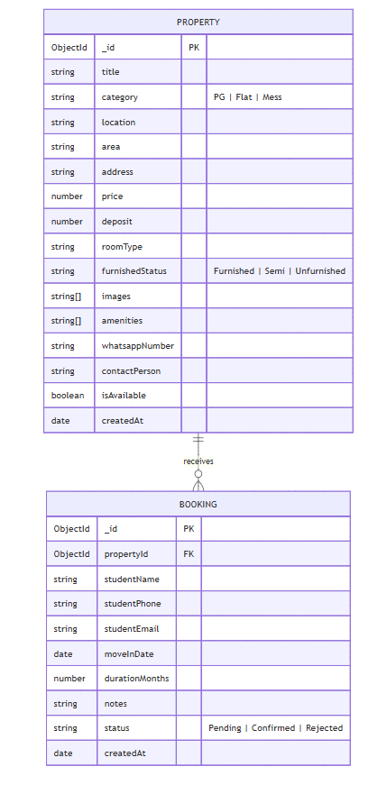

💻 Tech Stack

Frontend
Tool | Version | Purpose
React | 18.3 | UI component framework
Vite | 5.3 | Build tool & dev server
Tailwind CSS | 3.4 | Utility-first styling
Lucide React | 0.395 | Icon library
Axios | 1.7 | HTTP client

Backend
Tool | Version | Purpose
Node.js | 20+ | Runtime
Express.js | 4.19 | REST API framework
Mongoose | 8.5 | MongoDB ODM
MongoDB Atlas | — | Cloud database
dotenv | 16.4 | Env variable management
cors | 2.8 | Cross-origin request handling

AI Chatbot
Tool | Version | Purpose
Python | 3.11+ | Runtime
Flask | latest | HTTP API server
Flask-CORS | latest | Cross-origin support
scikit-learn | latest | TF-IDF + Logistic Regression
joblib | latest | Model serialization (.pkl)
pandas / numpy | latest | Data handling

DevOps & Infrastructure
Tool | Purpose
Docker | Container runtime
Docker Compose v2 | Multi-service orchestration
nginx:stable-alpine | Static file serving + reverse proxy

🔑 Admin Portal & Workflow
Access via the "Admin Portal" button in the navbar.
Listing Management:
- Add properties with image URLs, amenities, prices, and WhatsApp numbers
- Edit or toggle availability of existing listings
- Remove out-of-service listings
Booking Management:
- Monitor real-time student reservation inquiries
- Mark as Confirmed or Rejected
- Contact applicants using recorded details

